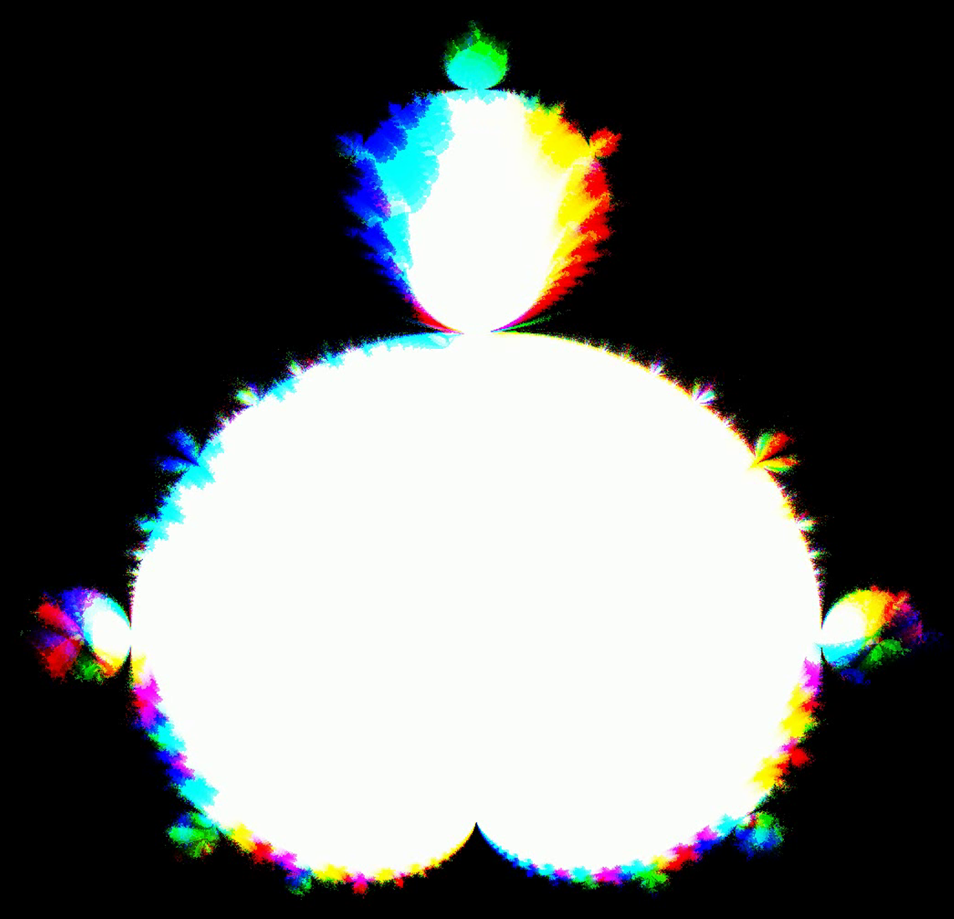

Most standard
higher dimensional
visualization techniques
compress or warp 4D data to
“fit” it into three dimensions.
I propose a novel visualization
technique - XYTC – that
represents 4D structures
losslessly.

XYTC was created by understanding
the dimensions through which the human eye
perceives. The retina detects light that strikes its 2D surface.
This immediately gives us two dimensions of data: X and Y. However,
the retina also detects a third dimension. That dimension is not Z (depth)
but color. Our retina perceives three independent units of information for every
photon that strikes the eye: x, y, and wavelength. By the definition of independence,
each can be treated as its own dimension.
However, there is more to perception than the retina. Our minds fundamentally exist in one
other dimension: time. Herein lies the fourth dimension of XYTC. Just as with color, we can reparameterize time as another spatial dimension.
So, we have four independent dimensions: where in X and Y the photon strikes the retina,
what color, C, is that photon, and when, T, does that photon strike the retina.
XYTC was crafted like a key to the lock of human visual perception. It makes full use
of every perceivable dimension. Nothing is wasted, every bit is semantic.
XYTC allows users to navigate in 4D space. To demonstrate its ability to
visualize any 4D shape, the system renders the Julia-Mandelbrot set -
a complex 4D fractal generalization of the 2D Mandelbrot set.
Download v0.1 for Windows.
Gif?
This piece is both interactive artwork and novel visualization technique. XYTC allows users to explore the stunning self-similarity and mathematical beauty of the Julia-Mandelbrot set and encodes semantically meaningful data of four dimensions.

I am conducting a study with Professor Elena Glassman measuring the accessibility of XYTC versus other 4D visualization techniques. Find a rough draft of the paper here.
For outreach, I am collaborating with educational YouTuber Purplemind on a video about XYTC. See our past research outreach.
In our world of higher-dimensional AI datasets and with a mounting need for beautiful and accessible communication of research, I believe XYTC is a salient new tool in the hands of researchers, artists, and designers.

Funding will be used to support the development of the outreach video, improve the quality of the study and resulting paper, and create a final installation.

Harvard Science center Julia set
Mandelbrot set graffiti at offsuit

